The Main Gate at the NASA Goddard Space Flight Center is located off Greenbelt Road (Maryland Rt. 193) at ICESat Road in Greenbelt, Maryland (AKA 8842 Greenbelt Rd).
This controlled-access facility requires all visitors of the Dance Club to check in at the GSFC Security Gate to obtain an access badge. You will need to show your picture ID.
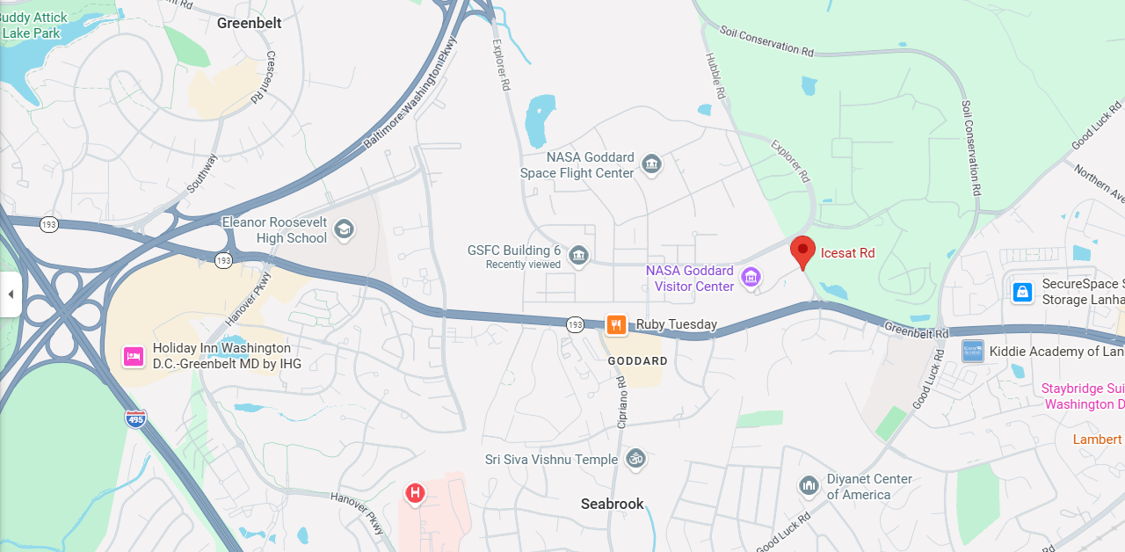
From the Main Gate, to get to the GEWA Recreation Center:
Make a RIGHT on Explorer Rd;
First RIGHT on Aqua road, and go past three intersections; follow signs for GEWA Recreation Center;
Once in the wooded area, at the fork make a RIGHT; you will see the Rec. Center parking in 500 feet.
